TOUR AND TRAVEL AGENCY

By

Group Members: FAYAZ AHMED (BS(IT)-2017-E05)

WALI MUHAMMAD (BS(IT)-2017-E27) ABDUL HAHI (BS(IT)-2017-E01)­

A final project report submitted in partial fulfillment of the requirements for the degree of **INFORMATION TECHNOLOGY**



Project Supervisor: AZAM KHAN

University of Baluchistan

Department of Computer Science and Information Technology

Pakistan

2017-2021

**CERTIFICATE OF APPROVAL:**

It is to certify that the final year project of BS "TOUR & TRAVEL SYSTEM” is developed by Students of BS(IT) 2017-21 Session, under the supervision of Sir, AZAM KHAN and that in their opinion: it is fully adequate, in scope and quality for the degree of BS in Information Technology.

_______________________________

Supervisor

_______________________________

External Examiner

_______________________________

Head of Department

(Department of Computer Science & Information Technology)

**Acknowledgements**

First of all, I am most grateful and extend our lovely appreciation to the mighty fortress is our Allah for giving us the endurance to complete this project, no doubt He is merciful and kind.

Sincere thanks go to our supervisor Sir, AZAM KHAN for his support throughout our entire project. His continuous suggestions, critics, adherence, and guidance made this project a success.

Department of Computer Science & IT, UOB, whose vast experience and knowledge with the needs and ideas of the subject matter were profoundly impactful in the successful completion of this undertaking. Without his supervision, advice, and valuable guidance, this project's completion would have been thankful. We are deeply indebted to him for this encouragement and continual help during the project

# Abstract

As the name specifies “TOUR & TRAVEL AGENCY” is software developed for managing tour booking.

Identification of the drawbacks of the existing system leads to the designing of computerized system that will be compatible to the existing system with the system Which is more user friendly and more GUI oriented. We can improve the efficiency of the system, thus overcome the drawbacks of the existing system.

* Less human error
* Strength and strain of manual labor can be reduced
* High security
* Data redundancy can be avoided to some extent
* Data consistency
* Easy to handle
* Easy data updating
* Easy record keeping
* Backup data can be easily generated

# Table of Contents

**Chapter Title Page**

Title Page i

Certificate of Approval ii

Acknowledgements iii

Abstract iv

Table of Contents v

1 Introduction 1

1.1 Motivation 1

1.2 Problem Statement 1

1.3 Objectives 1

1.4 Existing System 2

1.5 Proposed System 2

2 Study of System 3

2.1 Feasibility Study 3

2.2 Feasibility Report 3

3 Functional Requirements 5

3.1 Modules 5

4 System Environment 7

4.1 Hardware Configuration 7

4.2 Software Configuration 7

4.3 PyCharm 7

4.4 XAMPP 9

5 Framework & Database 10

5.1 Flask Framework 10

5.2 MySQL 12

6 SDLC Methodologies 16

6.1 Spiral Model 16

6.2 Performance Requirements 18

7 Diagrams 19

7.1 Data Flow Diagram 19

7.2 Unified Modeling Language 21

7.3 Entity Relationship Diagram 23

8 Database Design 25

8.1 Database Tables & Structure 25

8.2 Architecture Flow 28

9 Conclusion & Bibliography 31

# List of Tables

**Table Description Page**

2.1Tour Packages 6

**Chapter 1**

**1.0 Introduction**

The Tour and Travel Agency is a web-based application. The main purpose of “Tour and Travels System” is to provide a convenient way for a customer to book their tour packages of favorite places, a web-based system that enables better management of tourists or customers in travel agencies, TRS is consist of all of the essential things that a tourist or customer would want in one place, saving time and resources searching for hotels and travel agencies. The system prioritizes safeguards by securing tourist and other data and only permitting authorized users access to these data.

* 1. **Motivation**

In this modern era of technologies internet and smart devices plays a very important role. Where manually work become so hard to retrieve and add data so in this era we need to work smart, the website and applications need to be developed to ease the work, the tourism website makes everything easy and time saving for travelers to choose where they want to spend their vacations

* 1. **Problem Statement**

In the existing system, each task is carried out manually and processing is also a tedious job. In previous system travelers were maintaining time table details manually in pen and paper, which was time taking and costly. The travelers were not able to achieve its need in time and also the results may not accurate. Because of the manual maintenance there are number of difficulties and drawbacks exist in the system. Some of them are:

**1.2.1 Drawbacks of the Existing System:**

* Increased transaction leads to increased source document and hence maintenance becomes difficult.
* If any admin, user entry is wrongly made then the maintenance becomes very difficult.
  1. **Objectives**

This application is developed to provide best travelling services to the customers and travel agents. We have developed tours and travel management system to provide a search platform where a tourist can find their tour places according to their choices. This system also helps to promote responsible and interesting tourism so that people can enjoy their holidays at their favorable places.

* The objective of the project is to develop a system that automates the processes and activities of a travel and tourism agency.
* The purpose is to design a system using which one can perform all operations related to traveling and sight-seeing.

**1.4 Existing System**

* In the present system a customer has to approach various agencies to find details of places and to book tickets.
* This often requires a lot of time and effort.
* A customer may not get the desired information from these offices and often the customer may be misguided.
* It is tedious for a customer to plan a particular journey and have it executed properly.

**1.5 Proposed System**

* The proposed system is a web based application and maintains a centralized repository of all related information.
* The system allows one to easily access the relevant information and make necessary travel arrangements.
* Users can decide about places they want to visit and make bookings online for travel and accommodation.

**Chapter 2**

**2.0 Study of the System**

To provide flexibility to the users, the interfaces have been developed that are accessible through a browser. The GUI’S at the top level have been categorized as

1. Administrative user interface
2. The operational or generic user interface

The ‘administrative user interface’ concentrates on the consistent information that is practically, part of the organizational activities and which needs proper authentication for the data collection. These interfaces help the administrators with all the transactional states like Data insertion, Data deletion and Data up-dation along with the extensive data search capabilities.

The ‘operational or generic user interface’ helps the end users of the system in transactions through the existing data and required services. The operational user interface also helps the ordinary users in managing their own information in a customized manner as per the included flexibilities.

**2.1 Feasibility Study**

**2.2 Feasibility Report**

Preliminary investigation examines project feasibility; the likelihood the system will be useful to the organization. The main objective of the feasibility study is to test the Technical, Operational and Economical feasibility for adding new modules and debugging old running system. All systems are feasible if they are given unlimited resources and infinite time. There are aspects in the feasibility study portion of the preliminary investigation:

* Technical Feasibility
* Operation Feasibility
* Economic Feasibility

**2.2.1 Technical Feasibility**

The Technical Feasibility

* Does the necessary technology exist to do what is suggested?
* Do the proposed equipment’s have the technical capacity to hold the data required to use the new system?
* Will the proposed system provide adequate response to inquiries, regardless of the number or location of users?
* Can the system be upgraded if developed?
* Are there technical guarantees of accuracy, reliability, ease of access and data security?

**2.2.2 Operational Feasibility**

Proposed projects are beneficial only if they can be turned out into information systems, which will meet the organization’s operating requirements. Operational feasibility aspects of the project are to be taken as an important part of the project implementation. Some of the important issues raised are to test the operational feasibility of a project includes the following: -

* Is there sufficient support for the management from the users?
* Will the system be used and work properly if it is being developed and implemented?
* Will there be any resistance from the user that will undermine the possible application benefits?

This system is targeted to be in accordance with the above-mentioned issues. Beforehand, the management issues and user requirements have been taken into consideration. So there is no question of resistance from the users that can undermine the possible application benefits.

The well-planned design would ensure the optimal utilization of the computer resources and would help in the improvement of performance status.

**2.2.3 Economic Feasibility**

A system can be developed technically and that will be used if installed must still be a good investment for the organization. In the economic feasibility, the development cost in creating the system is evaluated against the ultimate benefit derived from the new systems. Financial benefits must equal or exceed the costs. The system is economically feasible. It does not require any additional hardware or software.

**Chapter 3**

**3.0 Functional Requirements**

# 3.1 Number of Modules

After careful analysis the system has been identified to have the following modules:

* **Administrator module**
* **User (Traveler) module**
* **Guest user**
  + 1. **Administrator module**

This module provides administrator related functionality. Administrator manages all information and has access rights to add, delete, edit and view the data related to places, travels, routes, bookings, Enquiries etc.

**Packages—**Admin will create the packages and Manage the packages(Create,Update,delete)

**Users-** Admin views all Information of all users.

**Booking-** Admin will responsible for manage booking. Admin can confirm and cancel a booking of traveler.

**Live Chat-** Admin can start or reply to the conversation of a registered user

**Manage Enquiries—**admin can manage all enquiries raised by users(traveler).

**Manage pages-** Admin can edit the info of all pages that are display on the website,

**Dashboard-** Here admin can view all count of booking, issues , Enquiries and Users .

**Change password---** Admin can change own password.

* + 1. **User (Traveler) module**

A registered user can have access to some more features:

**Signup-** User can register himself for booking.

**Sign in-** Here user can login with valid username and password.

**Live Chat—**User can start a live conversation with admin to solve any queries.

**My Profile-** user can update own profile.

**Tour history-**After login user can book any tour that will show in Tour history.

**Change Password----** User can own Password.

* + 1. **Guest Module**

Guest user can visit the website and view the all content of website in public domain. Guest user can also submit Enquiry.

**Chapter 4**

**4.0 System Environment**

**4.1 Hardware Configuration**

* + - Pentium IV Processor
    - 512 MB RAM
    - 40 GB HDD
    - 1024 * 768 Resolution Color Monitor

**Note:** This is not the “System Requirements**”.**

**4.2 Software Configuration**

* OS : Windows XP
* PyCharm, VS Code to Run Flask
* PhpMyAdmin or MySQL Server

**4.3 PyCharm**

PyCharm is a hybrid platform developed by JetBrains as an IDE for Python. It is commonly used for Python application development. Some of the unicorn organizations such as Twitter, Facebook, Amazon, and Pinterest use PyCharm as their Python IDE!

**It supports two versions: v2.x and v3.x.**

We can run PyCharm on Windows, Linux, or Mac OS. Additionally, it contains modules and packages that help programmers develop software using Python in less time and with minimal effort. Further, it can also be customized according to the requirements of developers.

### **Features of PyCharm: Why should we use it for our next Python project?**

Below, we have compiled some of the essential features provided by PyCharm.

**4.3.1 Intelligent Code Editor:**

* It helps us write high-quality codes!
* It consists of color schemes for keywords, classes, and functions. This helps increase the readability and understanding of the code.
* It helps identify errors easily.
* It provides the autocomplete feature and instructions for the completion of the code.

**4.3.2 Code Navigation:**

* It helps developers in editing and enhancing the code with less effort and time.
* With code navigation, a developer can easily navigate to a function, class, or file.
* A programmer can locate an element, a symbol, or a variable in the source code within no time.
* Using the lens mode, further, a developer can thoroughly inspect and debug the entire source code.
  + 1. **Refactoring**
* It has the advantage of making efficient and quick changes to both local and global variables.
* Refactoring in PyCharm enables developers to improve the internal structure without changing the external performance of the code.
* It also helps split up more extended classes and functions with the help of the extract method.
  + 1. **Assistance for Many Other Web Technologies:**
* It helps developers create web applications in Python.
* It supports popular web technologies such as HTML, CSS, and JavaScript.
* Developers have the choice of live editing with this IDE. At the same time, they can preview the created/updated web page.
* The developers can follow the changes directly on a web browser.
* PyCharm also supports AnglularJS and NodeJS for developing web applications.

**4.3.5 Support for Popular Python Web Frameworks**

* PyCharm supports web frameworks such as Django.
* It provides the autocomplete feature and suggestions for the parameters of Django.
* It helps in debugging the codes of Django.
* It also assists web2py and Pyramid, the other popular web frameworks.

**4.3.6 Assistance for Python Scientific Libraries**

* PyCharm supports Python’s scientific libraries such as Matplotlib, NumPy, and Anaconda.
* These scientific libraries help in building projects of Data Science and Machine Learning.
* It consists of interactive graphs that help developers understand data.
* It is capable of integrating with various tools such as IPython, Django, and Pytest. This integration helps innovate unique solutions.

**4.4 XAMPP SERVER**

XAMPP is one of the widely used cross-platform web servers, which helps developers to create and test their programs on a local webserver. It was developed by the **Apache Friends**, and its native source code can be revised or modified by the audience. It consists of **Apache HTTP Server, MariaDB, and interpreter** for the different programming languages like PHP and Perl. It is available in 11 languages and supported by different platforms such as the IA-32 package of Windows & x64 package of macOS and Linux.

XAMPP is an abbreviation where **X stands for Cross-Platform, A stands for Apache, M stands for**[**MYSQL**](https://www.javatpoint.com/mysql-tutorial)**, and the Ps stand for PHP and Perl**, respectively. It is an open-source package of web solutions that includes Apache distribution for many servers and command-line executables along with modules such as Apache server, MariaDB, PHP, and Perl.

XAMPP helps a local host or server to test its website and clients via computers and laptops before releasing it to the main server. It is a platform that furnishes a suitable environment to test and verify the working of projects based on Apache, Perl, MySQL database, and PHP through the system of the host itself. Among these technologies, Perl is a programming language used for web development, PHP is a backend scripting language, and MariaDB is the most vividly used database developed by MySQL. The detailed description of these components is given below.

**Chapter 5**

**5.0 Flask and MySQL**

**5.1 Flask**

Flask is a web application framework written in Python. It was developed by Armin Ronacher, who led a team of international Python enthusiasts called Poocco. Flask is based on the Werkzeg WSGI toolkit and the Jinja2 template engine.Both are Pocco projects.

### 5.1.1 WSGI

The Web Server Gateway Interface (Web Server Gateway Interface, WSGI) has been used as a standard for Python web application development. WSGI is the specification of a common interface between web servers and web applications.

### 5.1.2 Werkzeug

Werkzeug is a WSGI toolkit that implements requests, response objects, and utility functions. This enables a web frame to be built on it. The Flask framework uses Werkzeg as one of its bases.

### 5.1.3 jinja2

jinja2 is a popular template engine for Python.A web template system combines a template with a specific data source to render a dynamic web page.

This allows you to pass Python variables into HTML templates like this:

|  |
| --- |
| <html>  <head>  <title>{{ title }}</title>  </head>  <body>  <h1>Hello {{ username }}</h1>  </body> </html> |

### 5.1.4 Microframework

Flask is often referred to as a microframework. It is designed to keep the core of the application simple and scalable.

Instead of an abstraction layer for database support, Flask supports extensions to add such capabilities to the application.

**5.1.5 Why is Flask a good web framework choice?**

Unlike the Django framework, Flask is very Pythonic. It’s easy to get started with Flask, because it doesn’t have a huge learning curve.

On top of that it’s very explicit, which increases readability. To create the “Hello World” app, you only need a few lines of code.

This is a boilerplate code example.

|  |
| --- |
| from flask import Flask app = Flask(__name__)  @app.route('/') def hello_world():  return 'Hello World!'  if __name__ == '__main__':  app.run() |
|  |

If you want to develop on your local computer, you can do so easily. Save this program as server.py and run it with python server.py.

|  |
| --- |
| $ python server.py  * Serving Flask app "hello"  * Running on http://127.0.0.1:5000/ (Press CTRL+C to quit) |

It then starts a web server which is available only on your computer. In a web browser open localhost on port 5000 (the url) and you’ll see “Hello World” show up.  
To host and develop online, you can use PythonAnywhere

Some example output:

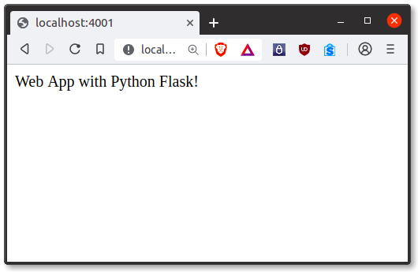

It’s a microframework, but that doesn’t mean your whole app should be inside one single Python file. You can and should use many files for larger programs, to handle complexity.

Micro means that the Flask framework is simple but extensible. You may all the decisions: which database to use, do you want an ORM etc, Flask doesn’t decide for you.

Flask is one of the most popular web frameworks, meaning it’s up-to-date and modern. You can easily extend it’s functionality. You can scale it up for complex applications

**5.2 MySQL**

What is a database? Quite simply, it’s an organized collection of data. A database management system (DBMS) such as Access, FileMaker Pro, Oracle or SQL Server provides you with the software tools you need to organize that data in a flexible manner. It includes facilities to add, modify or delete data from the database, ask questions (or queries) about the data stored in the database and produce reports summarizing selected contents.

MySQL is a multithreaded, multi-user SQL database management system(DBMS). The basic program runs as a server providing multi-user access to a number of databases. Originally financed in a similar fashion to the JBoss model, MySQL was owned and sponsored by a single for-profit firm, the Swedish company MySQLAB now a subsidiary of Sun Microsystem , which holds the copyright to most of the codebase. The project’s source code is available under terms of the GNU General Public Licence, as well as under a variety of pro prietory agreements.

MySQL is a database. The data in MySQL is stored in database objects called tables. A table is a collections of related data entries and it consists of columns and rows. Databases are useful when storing information categorically. A company may have a database with the following tables: “Employees”, “Products”, “Customers” and “Orders”.

**5.2.1 Database Tables**

A database most often contains one or more tables. Each table is identified by a name (e.g. “Customers” or “Orders”). Tables contain records (rows) with data.

**5.2.2 Queries**

A query is a question or a request. With MySQL, we can query a database for specific information and have a record set returned.

**5.2.3 Create a connection to a database**

Before you can access data in a database, you must create a connection to the database.In Flask , this is done with the app.config['SQLALCHEMY_DATABASE_URI'] function.

**Syntax**

basedir = os.path.abspath(os.path.dirname(__file__))

app = Flask(__name__)

app.config['SQLALCHEMY_DATABASE_URI'] =\

'sqlite:///' + os.path.join(basedir, 'database.db')

app.config['SQLALCHEMY_TRACK_MODIFICATIONS'] = False

db = SQLAlchemy(app)

**5.2.4 Create a Database**

The CREATE DATABASE statement is used to create a database in MySQL.

**Syntax**

CREATE DATABASE database_name

**5.2.5 Create a Table**

The CREATE TABLE statement is used to create a table in MySQL

**Syntax**

CREATE TABLE table_name(ncolumn_name1 data_type, column_name2 data_type, column_name3 data_type, ....)

**2.3.1.2.3 MySQL Functions**

mysql_affected_rows — Get number of affected rows in previous MySQL operation mysql_change_user — Change logged in user of the active connection mysql_client_encoding — Returns the name of the character set

mysql_close — Close MySQL connection

mysql_connect — Open a connection to a MySQL Server

mysql_create_db — Create a MySQL database

mysql_data_seek — Move internal result pointer

mysql_db_name — Get result data

mysql_db_query — Send a MySQL query

mysql_drop_db —Drop (delete) a MySQL database

mysql_errno — Returns the numerical value of the error message from previous MySQL operation mysql_error — Returns the text of the error message from previous MySQL operation mysql_escape_string — Escapes a string for use in a mysql_query

mysql_fetch_array — Fetch a result row as an associative array, a numeric array, or both mysql_fetch_assoc — Fetch a result row as an associative array

mysql_fetch_field — Get column information from a result and return as an object mysql_fetch_lengths — Get the length of each output in a result

mysql_fetch_object — Fetch a result row as an object

wsmysql_num_rows — Get number of rows in result

mysql_pconnect — Open a persistent connection to a MySQL server

mysql_ping — Ping a server connection or reconnect if there is no connection

mysql_query — Send a MySQL query

mysql_result — Get result data

mysql_select_db — Select a MySQL database

mysql_set_charset — Sets the client character set

mysql_stat — Get current system status

mysql_tablename — Get table name of field

mysql_thread_id — Return the current thread ID

mysql_unbuffered_query — Send an SQL query to MySQL, without fetching and buffering the result

**Chapter 6**

**6.0 SDLC Methodology**

This document play a vital role in the development of life cycle (SDLC) as it describes the complete requirement of the system. It means for use by developers and will be the basic during testing phase. Any changes made to the requirements in the future will have to go through formal change approval process.

**6.1 SPIRAL MODEL**

was defined by Barry Boehm in his 1988 article, “A spiral Model of Software Development and Enhancement. This model was not the first model to discuss iterative development, but it was the first model to explain why the iteration models.

As originally envisioned, the iterations were typically 6 months to 2 years long. Each phase starts with a design goal and ends with a client reviewing the progress thus far. Analysis and engineering efforts are applied at each phase of the project, with an eye toward the end goal of the project.

The steps for Spiral Model can be generalized as follows:

* The new system requirements are defined in as much details as possible. This usually involves interviewing a number of users representing all the external or internal users and other aspects of the existing system.
* A preliminary design is created for the new system.
* A first prototype of the new system is constructed from the preliminary design. This is usually a scaled-down system, and represents an approximation of the characteristics of the final product.
* A second prototype is evolved by a fourfold procedure:

1. Evaluating the first prototype in terms of its strengths, weakness, and risks.
2. Defining the requirements of the second prototype.
3. Planning an designing the second prototype.
4. Constructing and testing the second prototype.

* At the customer option, the entire project can be aborted if the risk is deemed too great. Risk factors might involved development cost overruns, operating-cost miscalculation, or any other factor that could, in the customer’s judgment, result in a less-than-satisfactory final product.
* The existing prototype is evaluated in the same manner as was the previous prototype, and if necessary, another prototype is developed from it according to the fourfold procedure outlined above.
* The preceding steps are iterated until the customer is satisfied that the refined prototype represents the final product desired.
* The final system is constructed, based on the refined prototype.
* The final system is thoroughly evaluated and tested. Routine maintenance is carried on a continuing basis to prevent large scale failures and to minimize down time.

**The following diagram shows how a spiral model acts like:**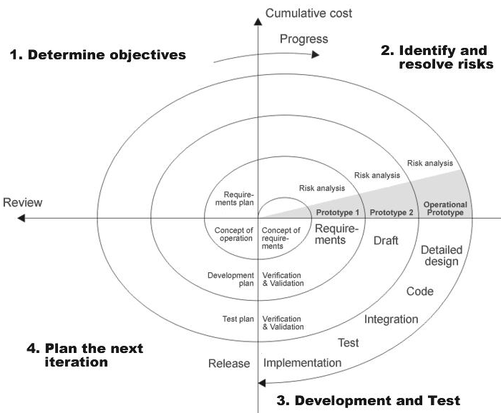

**Advantages:**

* Estimates(i.e. budget, schedule etc .) become more relistic as work progresses, because important issues discoved earlier.
* It is more able to cope with the changes that are software development generally entails.

Software engineers can get their hands in and start woring on the core of a project earlier

**6.2 Performance Requirements:**

Performance is measured in terms of the output provided by the application. Requirement specification plays an important part in the analysis of a system. Only when the requirement specifications are properly given, it is possible to design a system, which will fit into required environment. It rests largely with the users of the existing system to give the requirement specifications because they are the people who finally use the system. This is because the requirements have to be known during the initial stages so that the system can be designed according to those requirements. It is very difficult to change the system once it has been designed and on the other hand designing a system, which does not cater to the requirements of the user, is of no use.

The requirement specification for any system can be broadly stated as given below:

* The system should be able to interface with the existing system
* The system should be accurate
* The system should be better than the existing system

The existing system is completely dependent on the user to perform all the duties.

**Chapter 7**

**7.0 Diagrams**

A **diagram** is a symbolic representation of information using visualization techniques. Or structural representation of something being designed.

**7.1 Data Flow Diagram**

A data flow diagram (DFD) **maps out the flow of information for any process or system**. It uses defined symbols like rectangles, circles and arrows, plus short text labels, to show data inputs, outputs, storage points and the routes between each destination.

**7.1.1 DFD(User)**

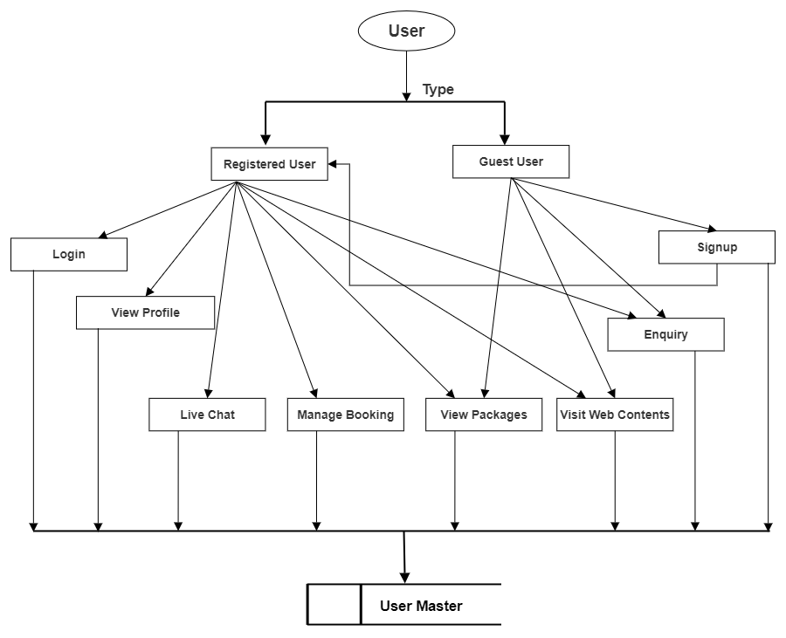 **7.1.2 DFD(Admin)**

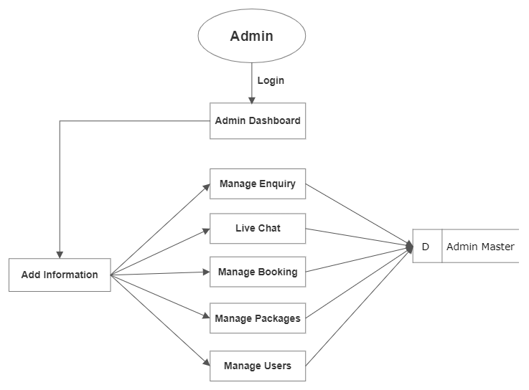

**7.1.3 Database Flow**

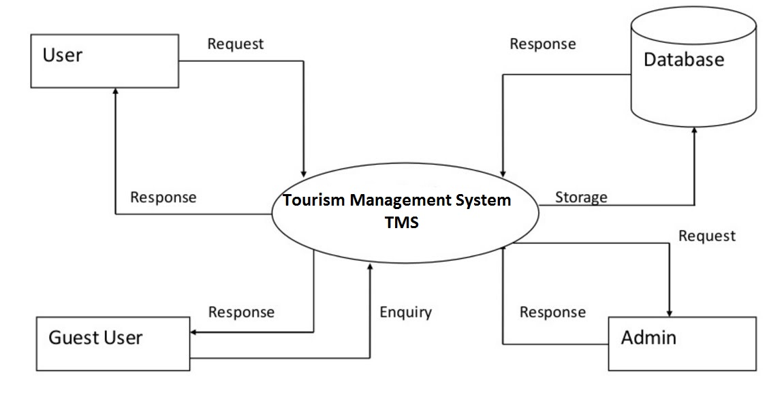

**7.1.4 Packages**

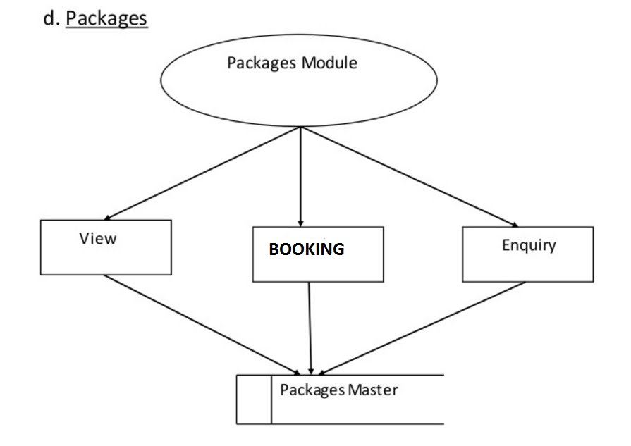

**7.2 UML Diagram**

The Unified Modeling Language is a general-purpose, developmental, modeling language in the field of software engineering that is intended to provide a standard way to visualize the design of a system.

**UML (USER)**

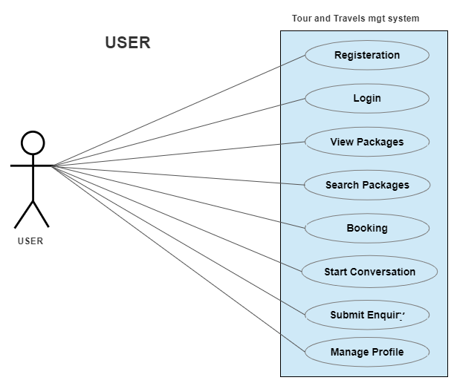

**UML(ADMIN)**

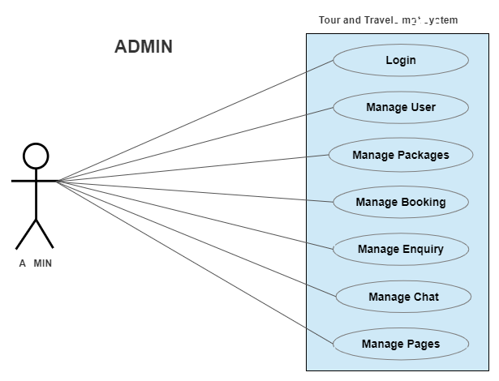

#### **7.3 ENTITY-RELATIONSHIP Diagrams**

E-R (Entity-Relationship) Diagram is used to represents the relationship between entities in the table.

The symbols used in E-R diagrams are:

SYMBOL PURPOSE

Represents Entity sets.

Represent attributes.

Represent Relationship Sets.

Line represents flow

Structured analysis is a set of tools and techniques that the analyst use to develop a new kind of a system:

The traditional approach focuses on the cost benefit and feasibility analysis, Project management, and hardware and software selection a personal consideration.

**ERD DIAGRAM**

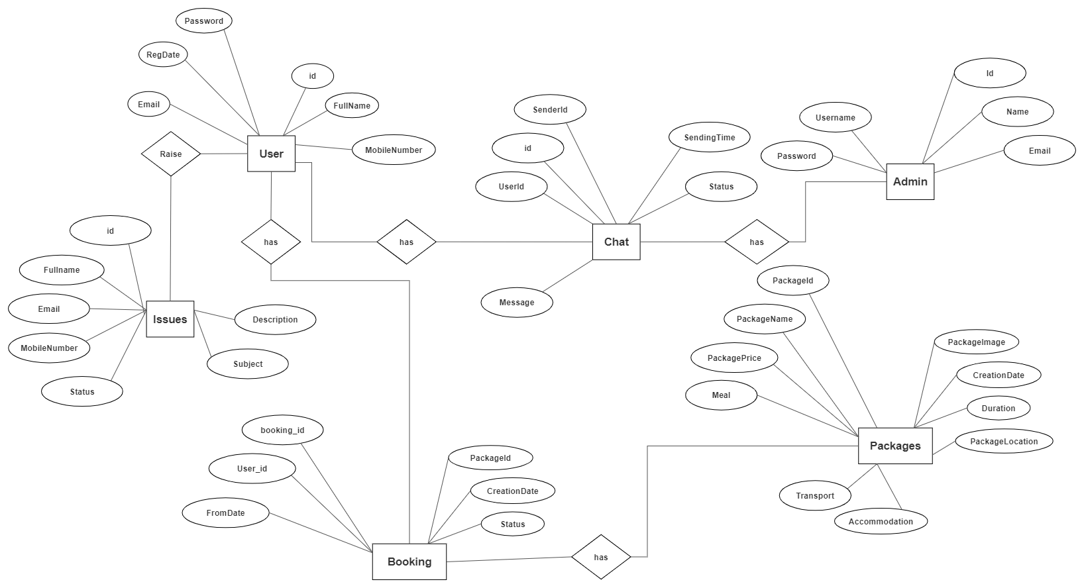

**Chapter 8**

**8.0 Database Design**

The data in the system has to be stored and retrieved from database. Designing the database is part of system design. Data elements and data structures to be stored have been identified at analysis stage. They are structured and put together to design the data storage and retrieval system.

A database is a collection of interrelated data stored with minimum redundancy to serve many users quickly and efficiently. The general objective is to make database access easy, quick, inexpensive and flexible for the user. Relationships are established between the data items and unnecessary data items are removed. Normalization is done to get an internal consistency of data and to have minimum redundancy and maximum stability.

This ensures minimizing data storage required, minimizing chances of data inconsistencies and optimizing for updates. The MySQL database has been chosen for developing the relevant databases.

**8.1 Database tables and Structure**

**Admin Table:** This table store the admin login details.

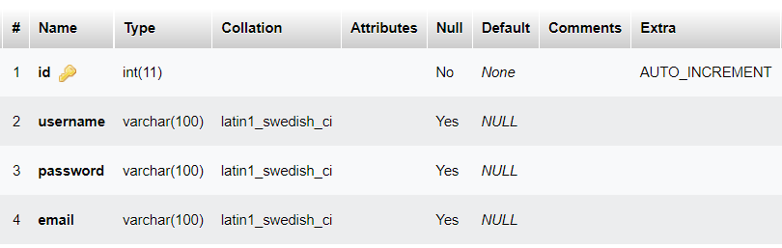

**tbluser table:** This table store the user personal and login details

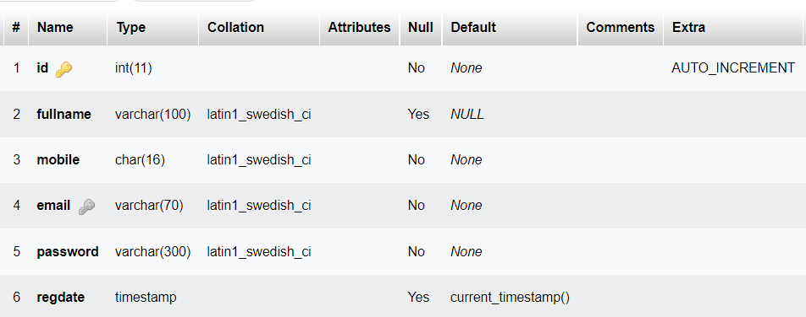

**tbltourpackages table:** This table store the tour package full details.

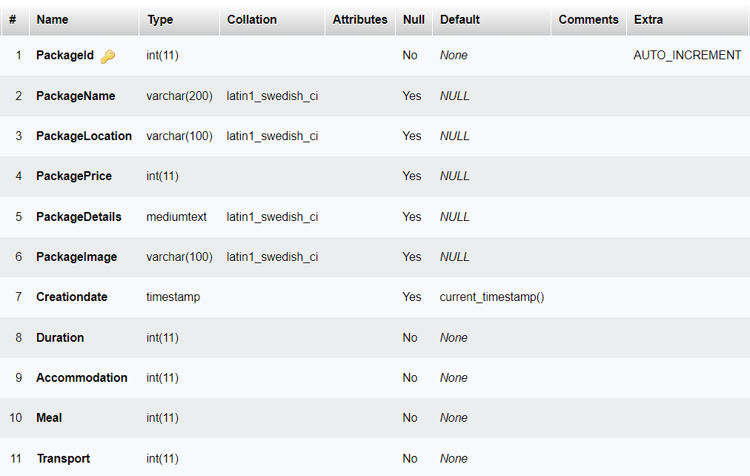

**tblbooking table:** This table store the user booking details.

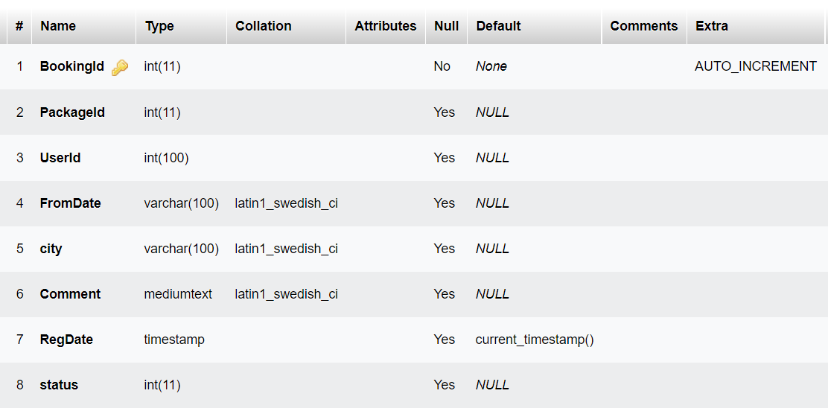

**tblenquiry table:** This table store the user enquiry details.

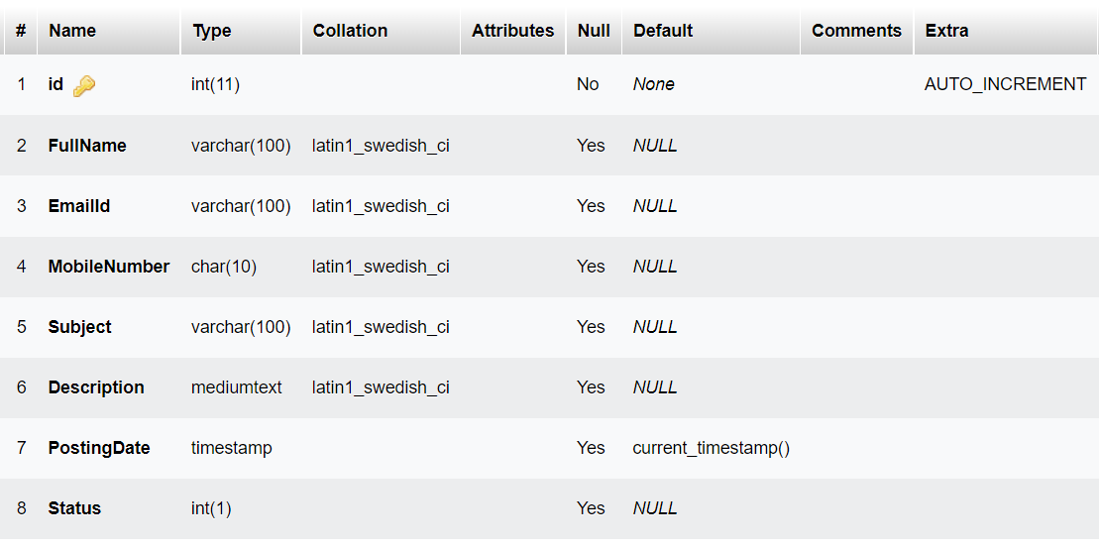

**tblpages table:** This table store the website pages details.

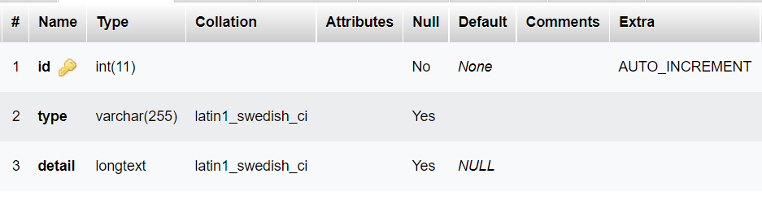

**About table:** This table store the company contact info.

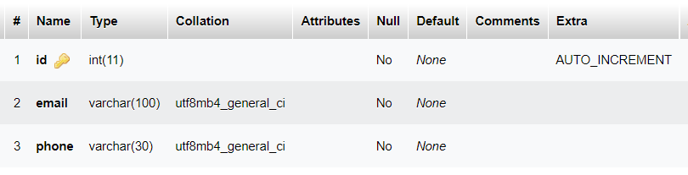

**Chat table:** This table store the conversation history of the costumers with admin

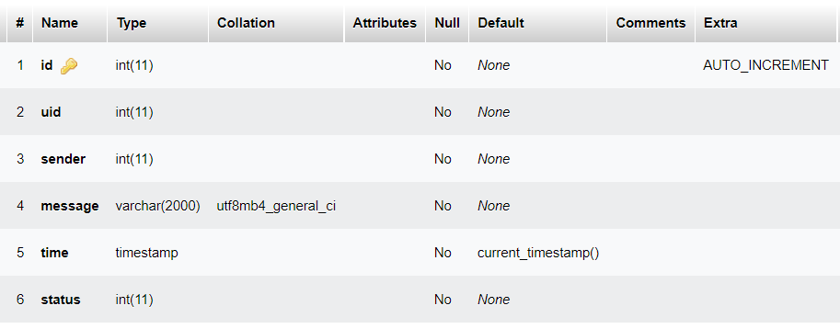

**8.2 Architecture flow :(N-Tier)**

N-Tier Applications can easily implement the concepts of Distributed Application Design and Architecture. The N-Tier Applications provide strategic benefits to Enterprise Solutions.

While 2-tier, client-server can help us create quick and easy solutions and may be used for Rapid Prototyping, they can easily become maintenance and security night mare The N-tier Applications provide specific advantages that are vital to the business continuity of the enterprise. Typical features of a real life n-tier may include the following:

* Security
* Availability and Scalability
* Manageability
* Easy Maintenance
* Data Abstraction

The above mentioned points are some of the key design goals of a successful n-tier application that intends to provide a good Business Solution.

**Definition:**

Simply stated, an n-tier application helps us distribute the overall functionality into various tiers or layers:

* Presentation Layer
* Business Logic layer
* Data Link Layer
* Database/Data Store

Each layer can be developed independently of the other provided that it adheres to the standards and communicates with the other layers as per the specifications. This is the one of the biggest advantages of the n-tier application. Each layer can potentially treat the other layer as a ‘Block-Box’. In other words, each layer does not care how other layer processes the data as long as it sends the right data in a correct format.

**Business Logic Layer**

**Presentation Layer**

**Request**

**Response**

**Data Link**

**Layer**

**Data Base**

**Fig: N-Tier Architecture**

**8.2.1 Presentation Layer**

Also called as client layer, comprises of components that are dedicated to presenting the data to the user. For example: Windows/Web Forms and buttons, edit boxes, Text boxes, labels, grids, etc.

* + 1. **Business Logic Layer**

This layer encapsulates the Business rules or the business logic of the encapsulations. To have a separate layer for business logic is of a great advantage. This is because any changes in Business Rules can be easily handled in this layer. As long as the interface between the layers remains the same, any changes to the functionality/processing logic in this layer can be made without impacting the others. A lot of client-server apps failed to implement successfully as changing the business logic was a painful process.

* + 1. **Data Link Layer:**

This layer comprises of components that help in accessing the Database. If used in the right way, this layer provides a level of abstraction for the database structures. Simply put changes made to the database, tables, etc do not affect the rest of the application because of the Data Access layer. The different application layers send the data requests to this layer and receive the response from this layer.

* + 1. **Database Layer:**

This layer comprises of the Database Components such as DB Files, Tables, Views, etc. The Actual database could be created using SQL Server, Oracle, Flat files, etc.

In an n-tier application, the entire application can be implemented in such a way that it is independent of the actual Database. For instance, you could change the Database Location with minimal changes to Data Access Layer. The rest of the Application should remain unaffected.

**Chapter 9**

**Conclusion**

Tourism is currently recognized as a global industry that is growing at a high rate, like any other industry. This web-based application helps in maintaining the database. It has a friendly environment that connects customers willingly. Thus, it simplifies the process by saving our time and efforts.

It will help tour managers to control and handle the tour-related activities effectively and efficiently. A further modification could be possible where the system can be integrated with bigger organizations such as tourist agencies in order to help them.

Identification of the drawbacks of the existing system leads to the designing of computerized system that will be compatible to the existing system with the system which is more user friendly and more GUI oriented.

**BIBILIOGRAPHY**

1. *www.w3schools.com*

*2. flask.palletsprojects.com/en/2.1.x*

*3.* [*www.tutorialspoint.com/flask/index.htm*](http://www.tutorialspoint.com/flask/index.htm)

*4.www.digitalocean.com/community/tutorials/how-to-make-a-web-application-using-flask-in-python-3*

*4. stackoverflow.com*